Work Name: | (Put in) (Jig) (Head Cover) (Jig Holder)
Step: | 4  Put the Pressing Jig in Jig Holder  - With right hand  - Aiming at the cut out in the lower side  - Put the Pressing Jig to the Jig Holder
Illustration:
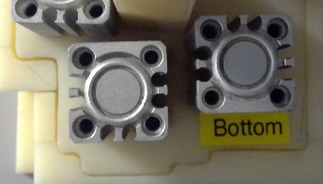
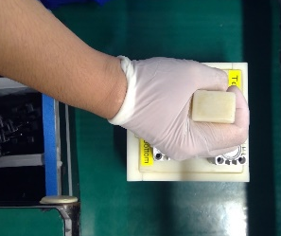
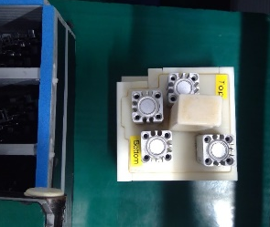
Cut out on lower side
Aim at the cut out on lower side
With right hand
Put down the Pressing Jig to the Jig Holder
- Aiming at the cut out in the lower side

Control Items | Position of the Jig Holder cut out To be in lower side

